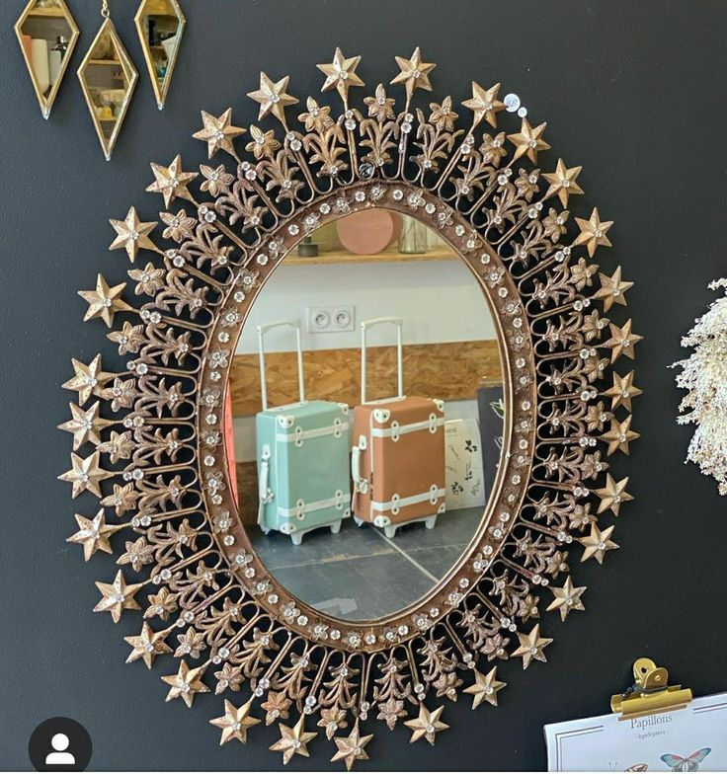**Radiant Charm with Iconic Star Mirrors**

When décor meets artistry, the result is stunning — and **Star Mirrors** are the perfect example. With their striking, often sunburst-inspired design, star mirrors bring a bold sense of personality and vintage glamour to any room. They are not just functional pieces, but eye-catching wall art that instantly elevates a space with their dynamic shapes and radiant energy.

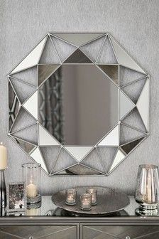Available in a range of styles — from mid-century metallic bursts to minimalist star outlines and intricately carved frames — our Star Mirrors are crafted with precision and premium materials. Each mirror features high-quality, distortion-free glass that reflects light beautifully while standing strong as a centerpiece in your décor.

Ideal for living rooms, hallways, bedrooms, or gallery walls, star mirrors work especially well as focal points. Their unique shape adds movement and interest to plain walls, making them excellent choices for creating visual drama without overwhelming a space. Whether you’re styling a chic modern apartment or a vintage-inspired home, a star mirror adds that touch of bold elegance your room has been waiting for.

Let your walls shine with brilliance and creativity — reflect your inner sparkle with a Star Mirror.